**OS Assignment # 1**

**Part B)** Download the latest stable kernel source and compile it. You can use following links to guide you

I have downloaded a kernel linux-4.20.7.tar and then extract it after that execute a command **make** to compile and install it by **make install.** But after reboot its gives me an error of ext4 mount drive.

**Part C)** Understand Pointers, Stack & Heap Memory, malloc: When I run the following code on PC**.**

* Local variables (declared and defined in functions) i.e ab, b & age are in **stack**
* Variables declared and defined in main function are not in **heap** are also in **stack**
* Pointers(ex: int *ptr, int *age) are in **heap** data or **stack**, depending on the context. C lets you declare a global or a **static pointer**, in which case the pointer itself would end up in the data segment.
* Dynamically allocated space(using malloc, calloc, realloc) are in **stack** or **heap**
* Function is based on a **stack**

**Screenshots**

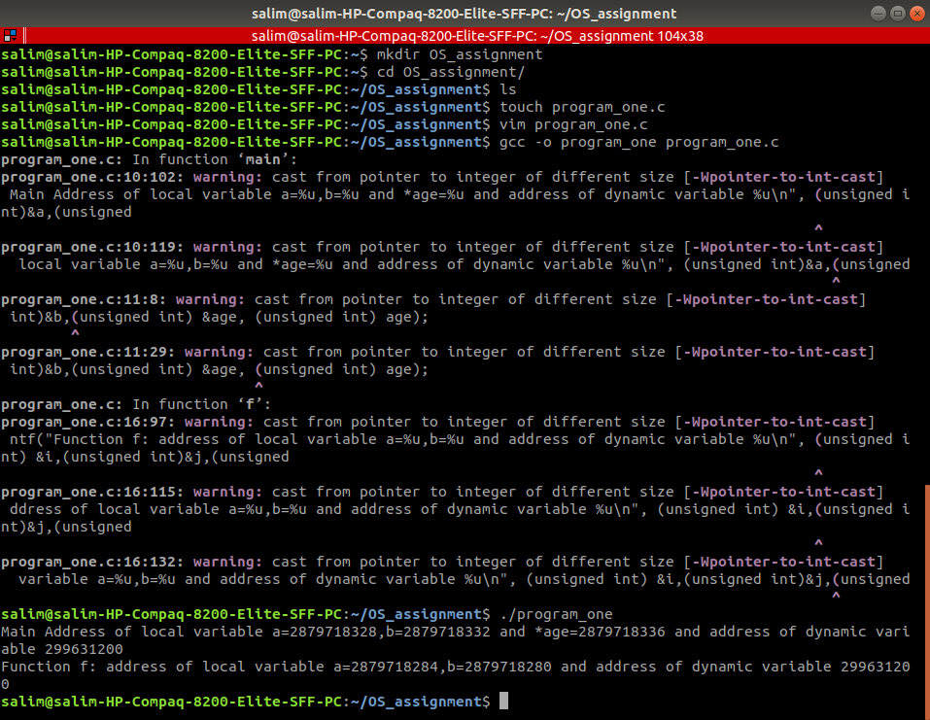

**Output:**

a=3212861652,b=3212861656 and *age=3212861660 and address of dynamic variable 158076936 Function f: address of local variable a=3212861616,b=3212861620 and address of dynamic variable 158076936

This numbers are the memory location that are assigned to the variables, pointers and function.

**Part D)** Compile the code in part-C with “-S” option into assembly and explain its outcome

gcc –S var.c –o var.asm

**Output:**

